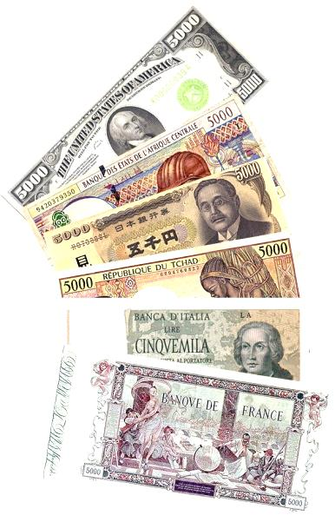
Money Money Money

1. how do clothes you spend on much month every?
>> How much do you spend on clothes every month?
You [ ] Partner_________________ [ ]
2. do you every day on how spend much snacks?
>>
You [ ] Partner_________________ [ ]
3. cost how shoes much did your?
>>
You [ ] Partner_________________ [ ]
4. how nantoka much your cost did ?
>>
You [ ] Partner_________________ [ ]
5. your how much set you did nantoka back?
>>
You [ ] Partner_________________ [ ]
6. much do phone how you pay for your month every?
>>
You [ ] Partner_________________ [ ]
7. pay for how books much did this you your school year?
>>
You [ ] Partner_________________ [ ]

