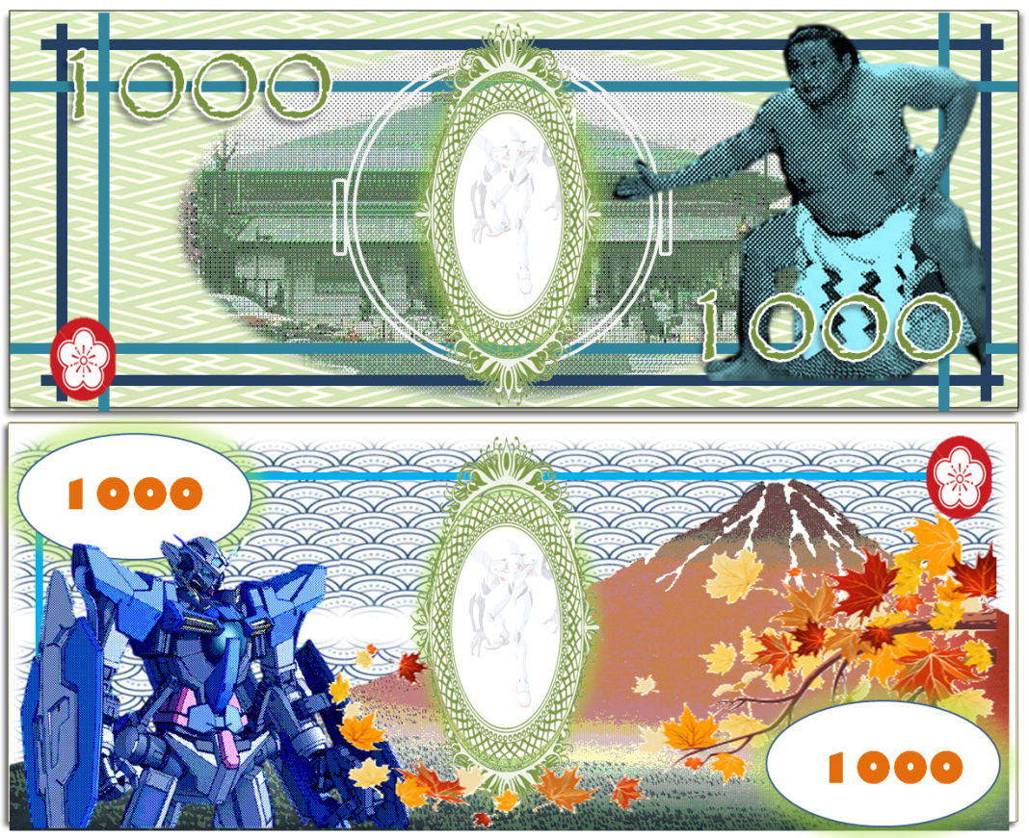
The new 1000 Yen Banknote

This is the new 1000 Yen banknote which was ……………… by Oshirika Yui and Oda Mari. The front of the banknote ……………… a number of traditional images. On the right is a ……………… of the sumo wrestler Takanohana. He symbolizes………………but also calm and self control. In the ……………… is an image of Ryogoku Kokugikan where sumo matches take place. This was included to represent ………… Japanese culture through sport and to ……………… sumo to tourists. The blue lines around the edge reflect the design of Japanese windows and again, represent traditional Japanese culture, but this time through simple design.
The reverse is a mix of ……………… and old to show that Japan is a modern country but with a lot of traditions. On the left is a portrait of the robot Gundam. He ……………… the fun Japanese contemporary spirit and the excitement of modern Japanese culture. On the right is the branch of a maple tree in Autumn ……………… This was included because the seasons in Japan are distinct and are an important part of Japanese ………………In the background is an image of Fuji, the most important natural symbol of Japan. The image was painted by Hokusai and also ……………… the long history of Japanese art. Hokusai is also quite well known in the West.
promote | portrait | traditional | power
designed | new | symbolizes | represents
colours | background | features | identity

