The 5000 Yen Banknote – More useful vocab for the presentation

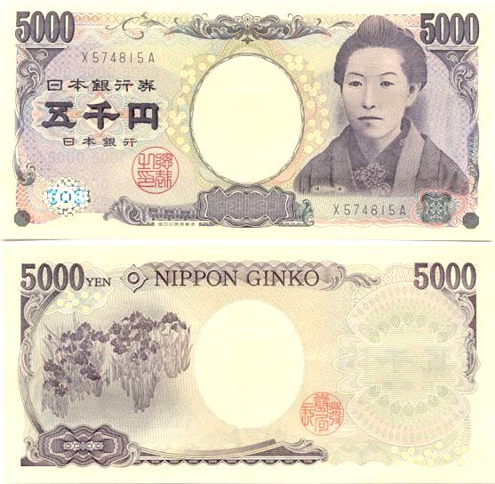
This is the Japanese 5000 Yen banknote. On the front it _________ a portrait of Higuchi Ichiyo, a popular Japanese writer from the 19th Century. She ___________ the long history of Japanese writing as well as being a symbol of the Meiji era when Japan started to become more international. However, she is dressed in a ____________ kimono and this might represent unique traditional Japanese culture. Finally we can suggest that Japan wants to show that women also have an important ______________ in Japanese culture because all of the other notes feature famous men.
On the ___________ is a painting of Irises by Ogata Korin, a 17th Century Japanese painter. This image symbolizes not only the beautiful nature in Japan but also the rich and varied _________ traditions of the country. Iris flowers also have great____________ in Japanese culture and __________ purity and protection from disease.
symbolizes | status | meaning | traditional
reverse | artistic | features | represent

